Currently all geometries in Rena only has translation DOFs.

**Distance-point-line constraint:**

Point is represented as: P(x, y)

Line is represented as: L (S, v), where S is the line’s start point, v is its direction vector which is constant.

Define the distance between them is: dist

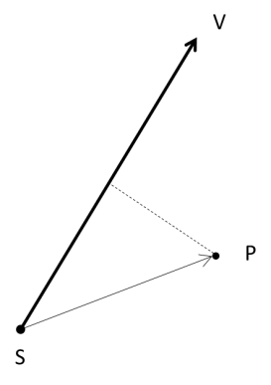

Hence,

$$d=\sqrt{\left(\vec{P}-\vec{S}\right)∙\left(\vec{P}-\vec{S}\right)- {((\vec{P}-\vec{S})∙\vec{V})}^{2}}$$

$$f=d-dist$$

Denote $\vec{Q}=\vec{P}-\vec{S}$

$$\frac{∂f}{∂P_{x}}=\frac{1}{2d}\left(2∙\frac{∂\vec{Q}}{∂P_{x}}∙\vec{Q}-2∙\vec{Q}∙\vec{V}∙\frac{∂\vec{Q}}{∂P_{x}}∙\vec{V}\right)=\frac{1}{d}\left(Q_{x}-\vec{Q}∙\vec{V}∙V_{x}\right)$$

$$\frac{∂f}{∂P_{y}}=\frac{1}{d}(Q_{y}-\vec{Q}∙\vec{V}∙V_{y})$$

$$\frac{∂f}{∂S_{x}}=\frac{1}{2d}\left(2∙\frac{∂\vec{Q}}{∂S_{x}}∙\vec{Q}-2∙\vec{Q}∙\vec{V}∙\frac{∂\vec{Q}}{∂S_{x}}∙\vec{V}\right)=\frac{1}{d}\left({-Q}_{x}+\vec{Q}∙\vec{V}∙V_{x}\right)$$

$$\frac{∂f}{∂S_{y}}=\frac{1}{d}\left({-Q}_{y}+\vec{Q}∙\vec{V}∙V_{y}\right)$$

I’ll test these derivative writing code.